TUITION ASSISTANCE
COORDINATORS
GUIDE

2023-2024
Awards

TABLE OF CONTENTS

- About The HALO Initiative ……………………….……………….….…………………………………………………………2

- 2023-2024 Timeline ……………………………………..………………………...............................................................3

- Application Rounds & Requirements
  - Priority Application Round …………..…………….…….….……………………………..…………………….4
  - Regular Application Round ……………..……………..………………………………………………………...5
  - Emergency Assistance …………………………..……………….…………………………………………………..6

- FACTS Grant & Aid
  - Annual Setup ..….………….…………………….……………………………………………………………………………7
  - Applying ………………………………………………….………….…………………………………………..………………..8
  - Supplemental Documents ……………………………………………………………………………….……….9
  - Non-Taxable Income Documents ………………………………………………………………………..10
  - Reviewing Applications ………………………………….……………………………………………….…………11

- Required Processes
  - Submitting Tuition Rates ………………………..………………………………………………………………..12
  - Student Verifications ……………………………………...………………………………………………..………..13

- Award Reallocation ……………………………………………………..….…………………………………………..……………14

- Promoting Tuition Assistance ………………………………………………………………………………….…………..15

- Communicating Awards to Families ……………………………………………………………………..…………16

- School Awarding Best Practices ………………………..………….………………………………………..………….17

- Other Scholarship Funds ………………………………………..……….…………………………………………………….18

Visit https://www.haloinitiative.org/tuition-assistance-coordinators to find sample letters, marketing materials, family application instructions, and other resources.
ABOUT THE HALO INITIATIVE

The HALO Initiative provides hope, opportunity, and access to all seeking a Catholic education in one of our Diocesan Catholic Schools. We believe that Catholic education changes lives & improves communities, and that a family’s ability to pay should not limit their access to a better life through one of our Catholic Schools.

Through coordinated partnership with Diocesan funds, scholarship organizations, and foundations, The HALO Initiative coordinates over $2.1 million in direct, need-based tuition assistance each year to students across Catholic schools in the diocese.

Jane Koenecke, Executive Director
jane@haloinitiative.org
972-232-2337

Brigid Compton, Funding and Project Specialist
brigid@haloinitiative.org
913-991-7571

FACTS Grant and Aid Customer Service
(for questions from families or schools)
866-412-4637

FUNDS
Students who apply are considered for an award from the following funds:
Fund Name | Type | Grades | Additional Criteria | Award Basis
DEET (Diocesan Education Endowment Trust) | Endowment | K-12 | none | FACTS Need
Collins Orphanage Trust | Endowment | K-12 | Students w/ parents who are deceased or incarcerated | FACTS Need
Golf Tournament Fund | Annual Fundraiser | K-8 | Schools in high need | FACTS Need
CHRISTUS Golf Scholarship |  | K-8 | 10 specific schools | FACTS Need
Our Faith Our Future Scholarships | Endowment | K-12 | none | FACTS Need
Saar Fund | Endowment | K-12 | none | FACTS Need

In addition to these funds, page 18 has information about the partner organizations that also offer support to students.
APPLICATION TIMELINE
2023-2024 SCHOOL YEAR

CURRENT FAMILIES
- November 1, 2022- January 5, 2023: Priority Application Round
- February 17, 2023: Priority Awards Announced to Schools
- March 3, 2023: Priority Student Award Acceptance due

ALL FAMILIES
- January 6, 2023-April 1, 2023: Regular Application Round
- May 12, 2023: Regular Awards Announced to Schools
- May 26, 2023: Regular Student Award Acceptance due

OTHER IMPORTANT DATES
FOR 2022-2023 AWARDS
- August 31, 2022: Fall Enrollment Verification Due in FACTS
- August 31, 2022: Fall Reallocation Request Forms Due to HALO
- January 13, 2023: Spring Enrollment Verification Due in FACTS
- January 13, 2023: Fall Reallocation Request Forms Due to HALO

FOR 2023-2024 AWARDS
- October 27, 2022: FACTS Term Setup Deadline
- January 17, 2023: Tuition Rates for 2024-2024 Due in FACTS
- January 27, 2023: Priority Applicant Verification Due

PARTNER SCHOLARSHIPS
ACE SCHOLARSHIPS
- March 1, 2023: Schools Receive Award Spots
- April 30, 2023: Applications Due in FACTS
JETHSUBY SCHOLARSHIPS (FACTS Application Required)
- January 1, 2023- February 24, 2023: Applications Due Online

PRIORITY APPLICATION ROUND

The Priority Application Round is open to families currently enrolled in any of the Diocese of Dallas Catholic Schools. The majority of funds will be given out to families who apply during this round.

Timeline | November 1, 2022 – January 5, 2023
Applicants | Families with a student enrolled at any diocesan school  for the 2022-2023 school year seeking tuition assistance for the 2023-2024 school year.
Requirements | - Completed FACTS Application  - 2021 Tax Return  - 2021 Supporting Tax Schedules, if applicable (Schedule C, etc.)  - 2021 W-2, if applicable  If family does not file taxes, they must include their non-taxable income and supporting documents. See page 10.
Award Criteria | Families will be ranked according to their percent of calculated need & awarded a percentage of that need until all funds have been reserved.
Awards Announced | February 18, 2023 (emailed to schools)
School Share Awards with Families | February 18-March 4  Parents should receive a letter from the school containing their award information.
Award Acceptance | March 4, 2023 (schools must accept awards in FACTS)

BENEFITS TO APPLYING EARLY
- Majority of awards are given out- less likely to get an award in Regular Round
- Can use all prior year tax information
- Will know their tuition assistance amount prior to the opening of enrollment

REGULAR APPLICATION ROUND

The Regular Application Round is open to any family, current or new, who wishes to apply for aid for the 2023-2024 School Year for a diocesan school. Only a small amount of funding will be reserved for this round.

Timeline | January 6, 2023 – April 1, 2023
Applicants | All families seeking tuition assistance for the 2023-2024 school year at any diocesan school.
Requirements | - Completed FACTS Application  - 2021 or 2022 Tax Return  - 2021 or 2022 Supporting Tax Schedules, if applicable (Schedule C, etc.)  - 2022 W-2, if applicable  If family does not file taxes, they must include their non-taxable income and supporting documents. See page 10.
Award Criteria | Families will be ranked according to their percent of calculated need & awarded a percentage of that need until all funds have been reserved.
Awards Announced | May 13, 2023 (emailed to schools)
School Shares Awards with Families | May 13- May 27  Parents should receive a letter from the school containing their award information.
Award Acceptance | May 27, 2023 (schools must accept awards in FACTS)

EMERGENCY ASSISTANCE

The Halo Initiative reserves a limited amount of funding each year for families who find themselves in an emergency during the school year. Emergencies include death or illness of someone in the family, destruction in the home due to fire/flood/natural disaster, incarceration or deportation of a family member, or other unforeseen circumstances.

To request emergency funding for a family, the school should:
- Mail/Email a request letter to HALO describing the need and listing the family’s remaining tuition payment as well as how much is needed

- If the family does not already have a FACTS application, they should complete one

- HALO will make a request to the DEET Committee and, once approved, will notify the school and a check will be sent directly to the school

The HALO Initiative does not accept requests for additional funding made by a family, rather any requests should come from the school on behalf of the family. This is to prevent any confusion or miscommunication between family and school.

FACTS GRANT & AID:
ANNUAL SETUP

Your FACTS account must be set up each year for the upcoming term. Schools cannot set up their own accounts- this must be done by your FACTS account representative. Deadline to complete your FACTS setup is October 27 be sure to contact your FACTS rep to schedule a time for this.

Follow these steps:
- Review your current year term set-up
  - Hover over the Grant & Aid tab at the top of your FACTS dashboard & click “Term Setup” from the dropdown
  - In the box on the left, click through the links to review each page

- Contact your FACTS Rep to either:
  - Copy your current year setup for next year or
  - Change/customize any portion of your setup

- Set up your Landing Page
  - When families click on your school’s unique link, they’ll be taken to a customizable landing page where you can put reminders or instructions on completing the Grant & Aid application.

Talk with your FACTS rep about using this feature. (if you use premier integration, families will access Grant & Aid via the parent portal)

- Set up Supplemental Documents
  - FACTS can be set up to require documents from families in addition to the standard tax & income verification documents. Talk with your FACTS rep about using this feature.

Premier Integration: This FACTS feature will integrate FACTS SIS (RenWeb) with FACTS Management, which includes Grant & Aid and Tuition Management. This integration eliminates the need for exporting/importing data between the two systems, allowing you to manage one family account where information is shared automatically between SIS and FACTS Management. Contact the CSO for more information about this free update.

FACTS GRANT & AID:
APPLYING

ELIGIBILITY
To be eligible to receive tuition assistance, a family/student must:
- Complete an application through FACTS Grant & Aid (must re-apply annually)
- Demonstrate financial need
- Meet the school’s entrance requirements
- Be current with all financial obligations due to any Catholic school within the diocese
Tuition assistance is awarded without regard for race, religion, gender, or ethnic origin.

HOW TO APPLY
- Log in or create an account using your school’s unique link or through www.online.factsmgt.com
  - Using the login from the prior year saves families time

- Complete the family application & pay the $40 application fee*

- Encourage family to add all expenses to application because it will impact the student percentage of tuition needed.
- Upload required supporting tax documents by photograph or scan

- Ensure that FACTS is added to family’s safe-sender list so they can receive updates about your application

*Your school can choose to pay the $40 application fee for a family:
- Have the family stop their application when they get to the payment page
- On the school side, open the Grant & Aid Dashboard, look in the Application Insights box for “Hidden Applications”, click “View”, and select “Pay Fee” for any family you wish.
- FACTS will bill the school for the fee

FACTS GRANT & AID:
SUPPLEMENTAL DOCUMENTS

Families will fill out the FACTS application and submit it, and then FACTS will request any applicable Supplemental Documents.
Families will remain in “SUB” or “Incomplete” status until these documents are submitted. FACTS can take up to two weeks to verify their receipt.

LIST OF REQUIRED DOCUMENTS
- Copy of 2021* or 2022 IRS Federal Form 1040, 1040A or 1040-EZ U.S. Individual Income Tax Return. If applicant and co-applicant file separately, we require both tax returns for the same tax year.
*some schools require the 2020 tax return for families

- Copies of all 2022* W-2 Wage and Tax Statements for both the applicant and co-applicant. NOTE: If you are applying before you have received all the 2022 W-2 Wage and Tax Statements, please submit them as soon as they become available.
*Priority Round (on/before January 5) may use 2021 W-2 Wage & Tax Statements

- Copies of all supporting tax schedules if you have income from any of the following:
  - BUSINESS – (Form 1040 Line 12) Attach Schedule C or C-EZ and Form 4562 Depreciation and Amortization
  - FARM – (Form 1040 Line 18) Attach Schedule F and Form 4562 Depreciation and Amortization
  - RENTAL PROPERTY – (Form 1040 Line 17) Attach Schedule E (page 1)
  - S-CORPORATION – (Form 1040 Line 17) Attach Schedule E (page 2), Form 1120S (4 pages), Schedule K-1 and Form 8825
  - PARTNERSHIP – (Form 1040 Line 17) Attach Schedule E (page 2), Form 1065 (5 pages), Schedule K-1 and Form 8825
  - ESTATES AND TRUSTS – (Form 1040 Line 17) Attach Schedule E (page 2), Form 1041 and Schedule K-1

- If you do not file income taxes and are unable to furnish a tax return or other tax schedules, you must provide copies of supporting documentation for Taxable Income, such as a letter from your employer.

- Copies of all supporting documentation for household Non-Taxable Income (see page 10).

Families must provide some form of documentation for any income they report.

FACTS GRANT & AID:
NON-TAXABLE INCOME DOCUMENTATION
Families must provide supporting documentation for any income listed the “Non-Taxable Income” section of the FACTS application. Examples include:

CHILD SUPPORT
  - Divorce decree showing amount
  - Court order showing amount

SOCIAL SECURITY BENEFITS
Social Security benefits received that were not taxed, such as SSI
  - SSI benefits statement

TEMPORARY ASSISTANCE FOR NEEDY FAMILIES (TANIF)
  - TANIF statement

WELFARE OR AID FOR FAMILIES WITH DEPENDENT CHILDREN (AFDC/ADC)
  - Statement of benefits
  - Claim form

FOOD STAMPS (SNAP)
  - Food Stamps Statement
  - Letter indicating amount received

WORKER’S COMPENSATION
  - Copy of the approved claim
  - Statement of benefits received

CLERGY/PASTORAL/MILITARY HOUSING ALLOWANCE
  - Copy of allowance check
  - Letter detailing benefits

TUITION SUPPORT FROM FAMILY/FRIENDS
  - Letter from supporter

OTHER NON-TAXABLE INCOME
If a family receives wages that do not appear on a W2 and that they do not claim, they should be added to this section of the application.
  - Letter from employer
  - Check stub(s)
A bank statement or a signed statement from the applicant will also be sufficient.
FACTS GRANT & AID:
REVIEWING APPLICATIONS

APPLICATION STATUS
In the Application Dashboard, applications will be in one of three statuses:
- VER- application & tax documents have been submitted. Applicant is eligible.

- DNF- applicant does not file taxes. HALO requires that families who do not file taxes still list their income and submit supporting documents. Check the “DNF VER” field to confirm that HALO has received these documents.

- SBM- application has been submitted, but the applicant has not submitted all of their tax documents or any supporting documents in lieu of tax documents. Application is incomplete. Applicant is ineligible.

INCOMPLETE APPLICATIONS
Applications are usually incomplete because they’re missing a supporting document.
- Be sure the applicant correctly answered all questions about taxable & non-taxable income (i.e. if they don’t receive a W2, be sure they responded “no” to the question that asks whether the applicant received a W2)
- If an application status is DNF, be sure the applicant still provided proof of income. Check the “Comments” for a note from HALO regarding any missing documents.

APPLICANT & STUDENT REPORTS
Use the standard reports or create your own, filter for certain dates or statuses, and print/view reports in excel.
In the Applications Dashboard, use the dropdown menu titled “Current Report” to navigate.

Visit www.resources.factsmgt.com and click “Grant & Aid” for more support.

FACTS GRANT & AID:
SUBMITTING TUITION RATES

Tuition assistance is awarded based on the family’s total tuition cost. No aid can be awarded until the school submits their 2023-2024 Tuition Rates to FACTS. There are two steps to this process:
- By January 17, 2023, email your 2023-2024 Tuition Rates to your FACTS rep. Include any non-parishioner or multi-family rate schedules.

- After the rates have been uploaded, open the HALO Student Verification Report (or any report with Student Tuition Schedule or Student Tuition).

Review the Tuition Schedule assigned to each student. To make changes, click the Open Column drop down and select “Student Tuition.” Then, you can edit multiple students at once.
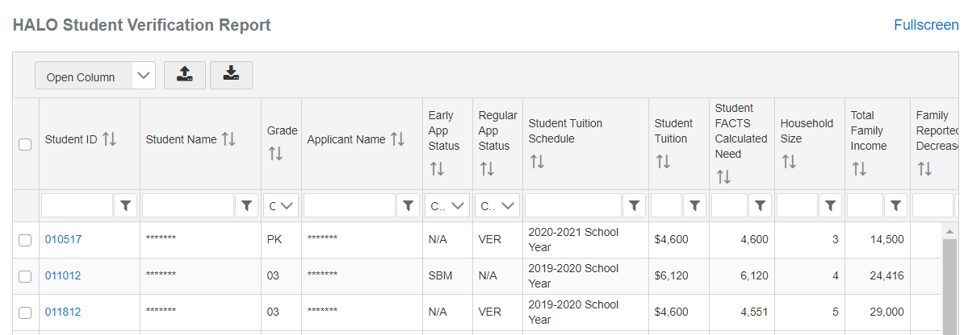

FACTS GRANT & AID:
STUDENT VERIFICATIONS

You will need to complete a verification four times each school year to confirm that students are enrolled in your school and that they accept their awards:
Award Acceptance:
- Priority Round Awards: Verify that students awarded in the Priority Round for 2023-2024 accept their awards by March 4, 2023

- Regular Round Awards: Verify that students awarded in the Regular Round for 2023-2024 accept their awards by May 27, 2023

Student Enrollment Verification:
- Fall: Verify that students receiving 2023-2024 awards are enrolled in the fall semester by August 31, 2023

- Spring: Verify that students receiving 2023-2024 awards are enrolled in the fall semester by January 14, 2024

To complete the verifications:
- You will receive an email from HALO when the verification opens
- Sign into FACTS and click “Complete your Student Verification” in the “Action Required” box (see image below)
- In the report, click “Yes” for all students who meet the qualification outlined at the top of the report.
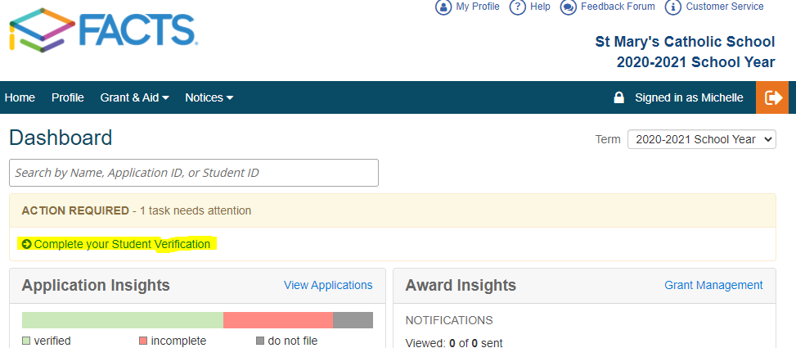

AWARD REALLOCATION POLICY

What happens when a family who was awarded through HALO chooses not to attend your school? Or, when a family with an award in another diocesan school wants to enroll in your school?

If a student chooses to enroll at another diocesan school…
- Both schools must notify HALO
- HALO will update the student’s application in FACTS with the new school’s information & allow FACTS to recalculate their need based on the new school’s cost of tuition
  - Remember that calculated need is based on the cost of tuition
- The student’s award will be updated based on a proportional percentage of their new calculated need (i.e. if they were originally awarded 30% of their calculated need, their award will be updated to reflect 30% of their new calculated need)
  - No student will receive a larger award than what they were originally awarded, even if their calculated need increases.
  - A student may receive a smaller award than what they had originally been given if their calculated need decreases at the new school. This portion of the award would then be moved back into the fund and awarded to the student with the next highest need across all applicants.

If a student chooses to enroll at a non-diocesan Catholic school or school outside of the diocese…
- The diocesan school will notify HALO
- The award will be moved back into the fund and awarded to the student with the next highest need across all applicants
- All reallocations must be rounded to the nearest tenth place for accounting purposes

If a student transfers to any diocesan or outside school after the start of the school year, the award will be reallocated within the original school.

Students who do not have a complete FACTS Grant & Aid application will not be eligible to receive reallocated funds.

Visit https://www.haloinitiative.org/tuition-assistance-coordinators to find the Reallocation Request form.
PROMOTING TUITION ASSISTANCE

The amount of aid a school receives from HALO for their families is based on how many families with high need apply.
- Identify Existing Communication Channels: How does your school already communicate with families? Website, email, flock notes, social media, notes home with students, parent phone calls- all of these are great ways to promote the tuition assistance application process.

- Identify Existing School Events: When will families already be in your building for celebrations, conferences, monthly meetings, enrollment information nights, open houses, etc.? Talk to them about tuition assistance, distribute flyers, or add a tuition assistance reminder to other handouts.

- Hold an Informational Session: Invite families or require them to attend an info session about tuition assistance.
Pro-tips:
  - Hold it after the Priority Round has opened so families can apply immediately after the session
  - Provide bilingual materials & have bilingual staff there to answer questions
  - Incentivize them by covering a discount on their FACTS application fee for coming

- Keep Open Computer Lab Hours: Schedule a few evenings throughout the semester where families can come to the school to use the computers & fax machine, and get help submitting their application. Have 2-3 staff members present, at least one who is bilingual.
Most importantly…
- Communicate! Use both mass communications & personal conversations to all your families. Make a list of families you know need to apply & invite them individually. Let parents know when they can come to the school to get help with their application.

COMMUNICATING AWARDS TO FAMILIES

Every school has a unique process for communicating financial aid and enrollment decisions to families. For this reason, The HALO Initiative does not send award letters directly to families and we ask that schools share award information.

Putting the information in writing allows you to guide the message families receive. Here is a suggested structure for a financial aid award letter:

- Greeting and celebration- it is going to be a great year!

- Talk about monthly payment amount instead of the amount of the awards they are receiving. This is the number that matters most to families.

- Remind them of the value of their investment and the experience their children will have that make tuition costs worthwhile.

- Outline the next step, whether it’s finishing enrollment or completing a tuition agreement in FACTS Tuition Management or contacting you to accept the award.

- Detail the office hours & contact information of the person they can contact to talk further about their aid or their admissions process.

To maximize readability and impact, the letter should be:

- No more than one page

- Bilingual, if necessary (English on front, Spanish on back)

- On your school’s letterhead or with your school’s logo

- Emailed as a PDF attachment or mailed

A sample award letter is available at https://www.haloinitiative.org/tuition-assistance-coordinators
SCHOOL AWARDING BEST PRACTICES

HALO awards are only part of the aid that most schools can offer to students. Every school has their own method of acquiring and awarding their own tuition assistance, and the CSO recommends that schools are accountable to maintaining an objective and consistent awarding process.

- Require that families complete a FACTS Grant & Aid application
  - FACTS is an objective 3rd party system that uses benchmarks from national research to determine student need. When your families use FACTS to apply for school awards, you can compare all applicants against consistent, objective criteria.

- Solidify your Eligibility Criteria and Awarding Metrics
  - Criteria: What does your school require students do to be eligible for funding? A completed FACTS application, completed enrollment, certain level of calculated need—all of these could be part of your criteria.
  - Awarding Metrics: How much aid does each student receive? A fixed amount for all students, a percentage of calculated need, a sliding scale based on calculated need—any of these and others could be your determining factor.

Some of these decisions may depend on the request of the donor or funder, and may be different whether you’re looking at a school fund or a parish fund. The important thing is to outline—even with just a few sentences—how the awarding is accomplished in each fund.

- Gather a Tuition Assistance Committee to make awarding decisions
  - A principal and a tuition assistance coordinator are not a committee. To ensure objectivity and accountability, awarding decisions or at least the final approval should be made by between 3-5 individuals, including someone from the school, the parish (ideally the pastor if applicable), and the parish finance council and/or school board, depending on the source of the funding.

OTHER SCHOLARSHIP FUNDS

ACE SCHOLARSHIPS (www.acescholarships.org)
ACE provides students from low-income families with access to quality, private K-12 schools through privately funded scholarships.

Once you partner with ACE, they will notify your school on March 1 of the number of scholarship slots you’ll receive. You have between March 1 and April 30 to submit your applications through FACTS.

JETHSUBY SCHOLARSHIP FUND (www.jethsuby.org)
Jethsuby was founded to give students with immigrant parents the best possible opportunity to succeed.

Eligible students are Latino children who have at least one parent born outside the United States and are enrolled in or have applied to a Diocese of Dallas Catholic elementary school in grades 1 – 8.

Families must complete a FACTS application, and apply via Jethsuby’s online application between January 1 and February 24 (the last Friday of February).

THE CATHOLIC FOUNDATION SCHOOL GRANTS
The Catholic Foundation provides grants directly to schools for tuition assistance. Contact the Catholic Foundation directly for more information.

REBEKAH LEAH RIVERA FOUNDATION (www.rebekahleahrivera.org)
The Rebekah Leah Rivera Foundation offers Spirit of Love Scholarships to Catholic student parishioners in the Catholic Diocese of Dallas in memory of Rebekah Rivera who passed away in June 2004. The Application and Email Submission Period is January 2, 2023 thru February 1, 2023. For eligibility requirements and applications, visit www.rebekahleahrivera.org or call 972-480-5273.

